/* Logan Kim */

/* COMP214-008 */

/* Assignment 1 */

/* Question 1 */

/* List the name of each officer who has reported more than the average number of crimes officers have reported */

SELECT co.officer_id, o.last, o.first

FROM crime_officers co

JOIN officers o

ON co.officer_id = o.officer_id

GROUP BY co.officer_id, o.last, o.first

HAVING COUNT(*) > (SELECT COUNT(*) / COUNT(DISTINCT officer_id)

FROM crime_officers);

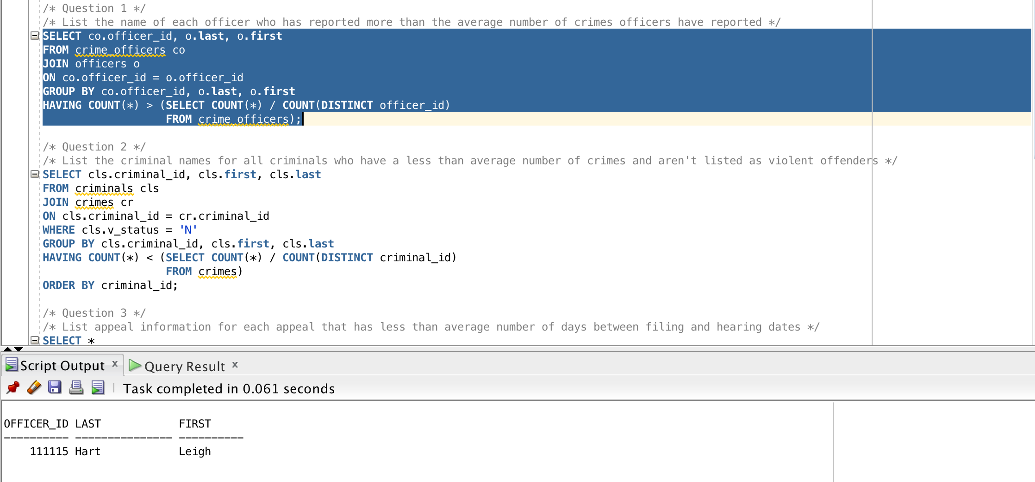

/* Question 2 */

/* List the criminal names for all criminals who have a less than average number of crimes and aren't listed as violent offenders */

SELECT cls.criminal_id, cls.first, cls.last

FROM criminals cls

JOIN crimes cr

ON cls.criminal_id = cr.criminal_id

WHERE cls.v_status = 'N'

GROUP BY cls.criminal_id, cls.first, cls.last

HAVING COUNT(*) < (SELECT COUNT(*) / COUNT(DISTINCT criminal_id)

FROM crimes)

ORDER BY criminal_id;

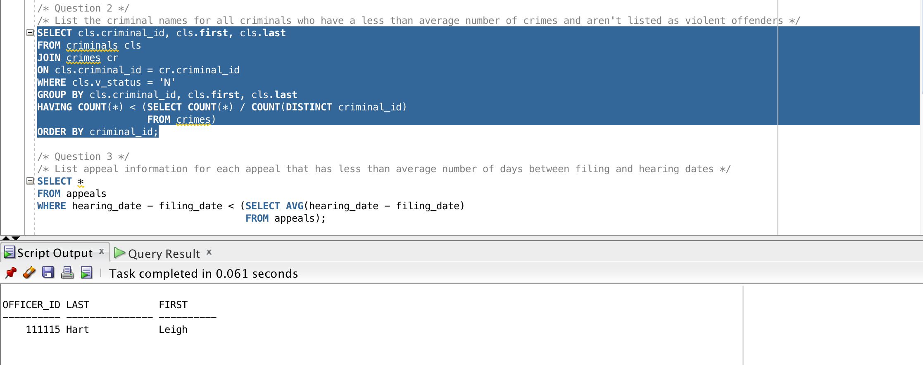

/* Question 3 */

/* List appeal information for each appeal that has less than average number of days between filing and hearing dates */

SELECT *

FROM appeals

WHERE hearing_date - filing_date < (SELECT AVG(hearing_date - filing_date)

FROM appeals);

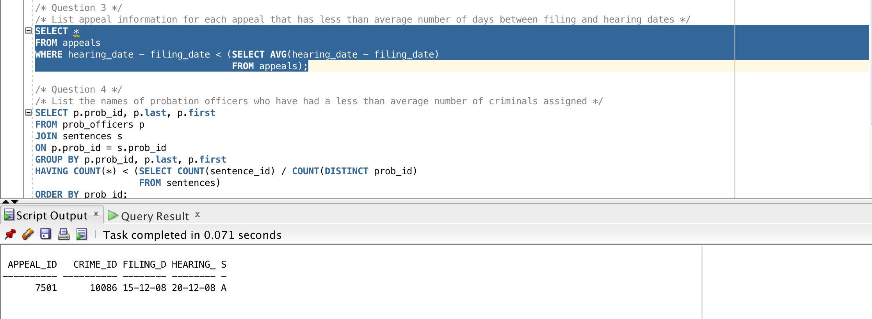

/* Question 4 */

/* List the names of probation officers who have had a less than average number of criminals assigned */

SELECT p.prob_id, p.last, p.first

FROM prob_officers p

JOIN sentences s

ON p.prob_id = s.prob_id

GROUP BY p.prob_id, p.last, p.first

HAVING COUNT(*) < (SELECT COUNT(sentence_id) / COUNT(DISTINCT prob_id)

FROM sentences)

ORDER BY prob_id;

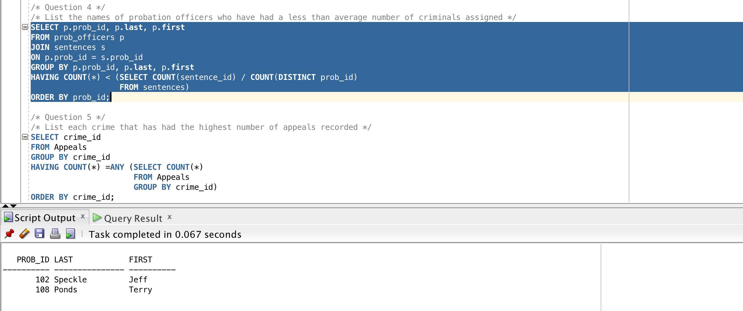

/* Question 5 */

/* List each crime that has had the highest number of appeals recorded */

SELECT crime_id

FROM Appeals

GROUP BY crime_id

HAVING COUNT(*) =ANY (SELECT COUNT(*)

FROM Appeals

GROUP BY crime_id)

ORDER BY crime_id;

